**Name: Ngô Việt Tiến**

**Roll number: SE161204**

**Computer Project**

*(Using: Minitab 20.3)*

1. 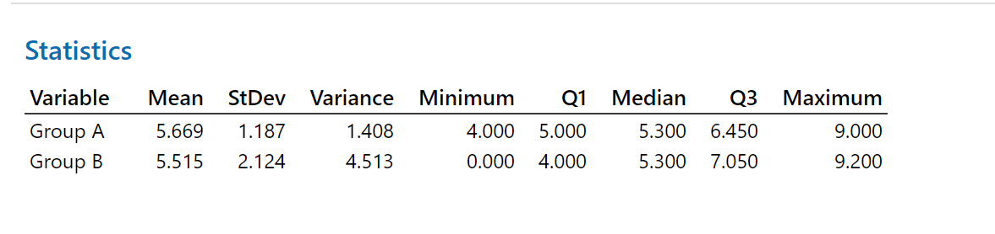

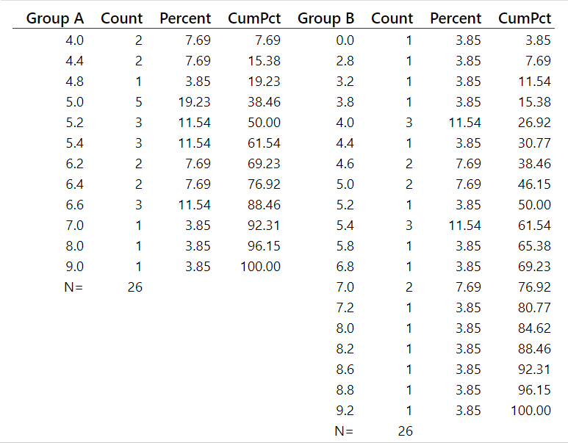Frequency distribution:

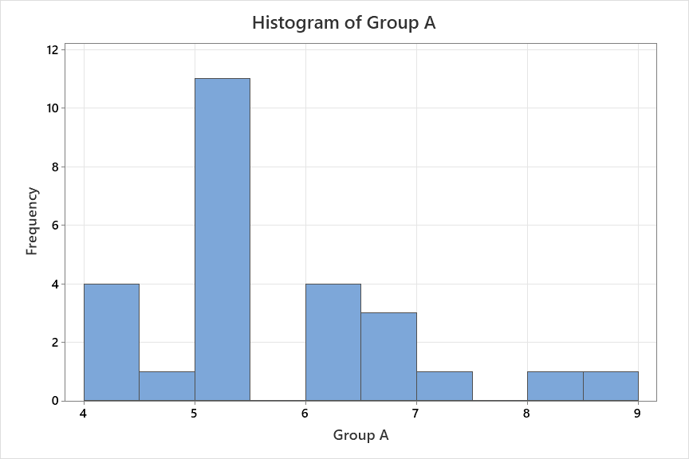Histogram of group A:

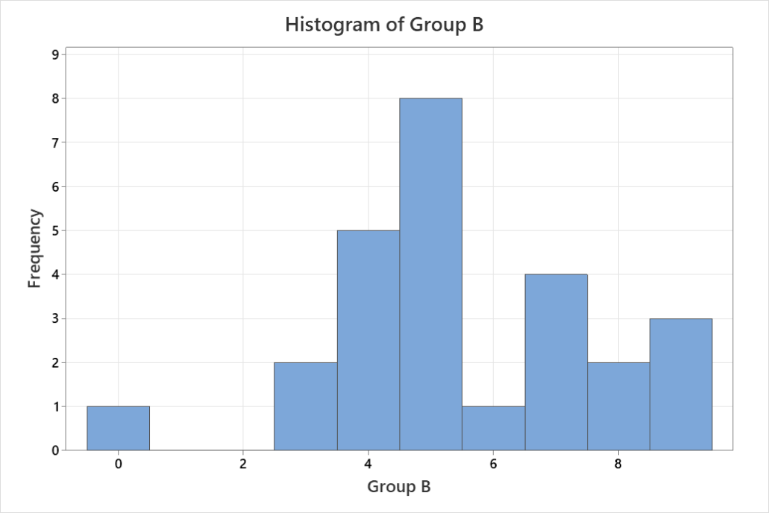Histogram of group B:



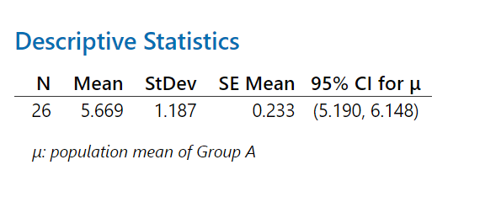Group A:

Group B:

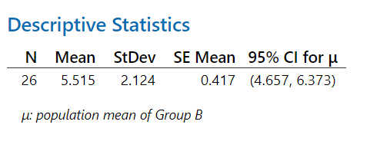



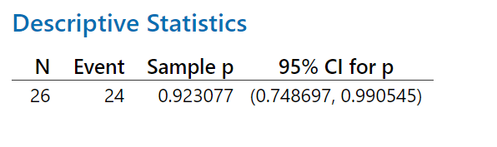Group A: 

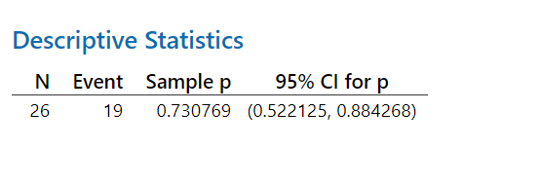 Group B: 

1. Group A: 
2. 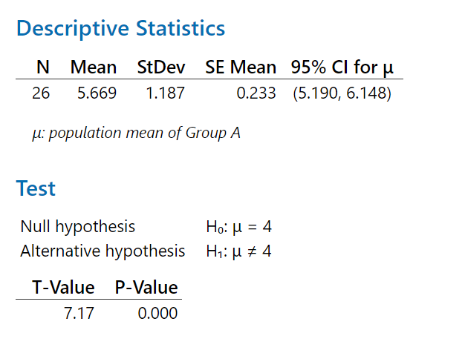

P-Value < => Reject H0 => Reject hypothesis average score = 4

1. 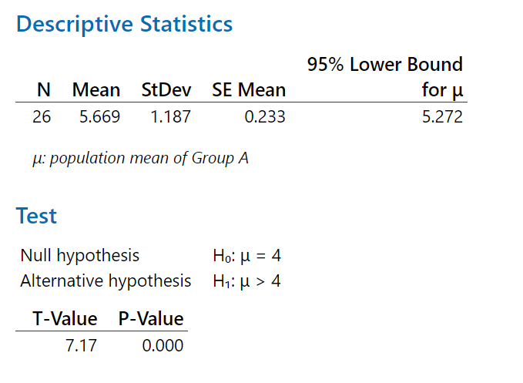

P-Value < => Reject H0 => Approve hypothesis average score > 4

1. Group B: 
2. 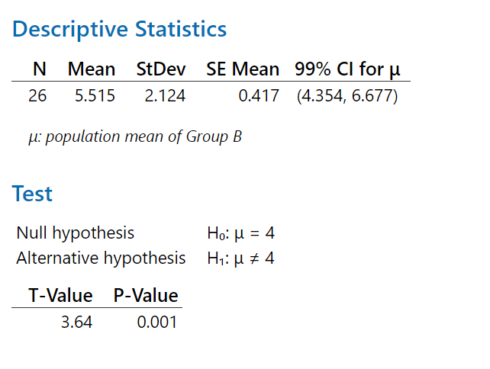

P-Value < => Reject H0 => Reject hypothesis average score = 4

1. 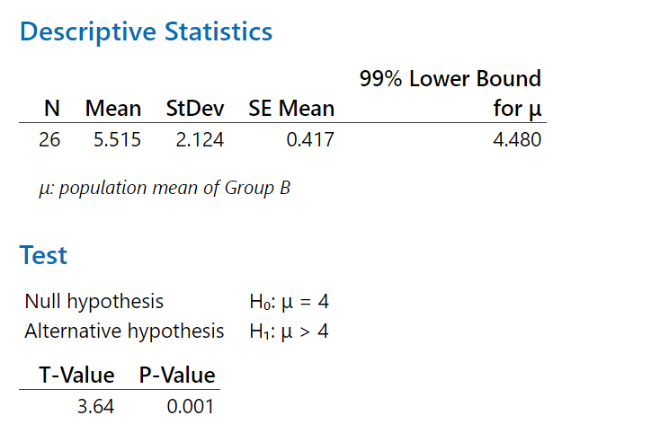

P-Value < => Reject H0 => Approve hypothesis average score > 4

1. 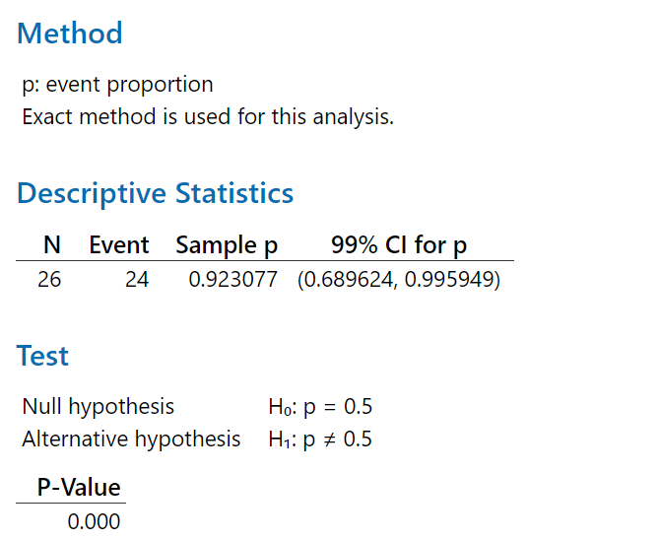Group A: , 

P-Value < => Reject H0 => Reject hypothesis the proportion of students whose score > 4 equals 50%.

1. Group B: , 

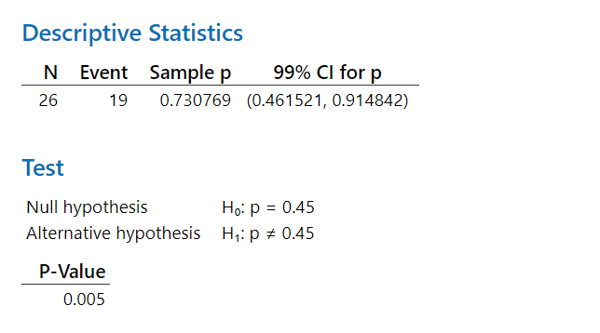

P-Value < => Reject H0 => Reject hypothesis the proportion of students whose score > 4 equals 45%.